Real-time agent brief introduction

DOC. No.: | REV.: 00 |  |  | PRODUCT:
TITLE: Real-time agent brief introduction |  |  |  | Project:
Prepared by: | Lewis |  |  | Date: | 2010-1-13
Remark: | Approval:
Remark: |  | Department | Title |  |  | Signature
Remark: | 1 | Electronic R&D
Remark: | 2
Remark: | 3
Remark: | 4

Revision | Description of Change | Author | Date
00 | First revision | Lewis Chen | 2010-1-13

1. Overview 4
1.1. Step1→Project setting 4
1.2. Step2→Modify main.c 5
1.2.1. Include the following file 5
1.2.2. Add the following line after interrupts_enable(TRUE); 6
1.3. API 6
1.3.1. void RTDBGPrintf(const char* str,...); 6
1.3.2. #define DEBUGMSG(cond,printf_exp) ((void)((cond)?(RTDBGPrintf printf_exp),1:0)) 6

Overview
This a article will give you a brief view about how to enable real-time agent when debugging software using Keil IDE.

Quick start

Step1→Project setting
- Create a new Group for the files in your Project Workspace called 'Real-Time Agent'
- Add the file http://10.10.0.45/source/trunk/libs/rt_agent/qs_rt_agent.c and http://10.10.0.45/source/trunk/libs/rt_agent/GNU/RT_Agent.c to this Group. (PS: RT_Agent.c shouldn’t be compiled to thumb code.)
- Open Options for project window, then go to CC, add the following Preprocessor Symbols ” Q_SPY __CPU_MODE__=1 DEBUG”
- Then include the 4 paths in the red frame: 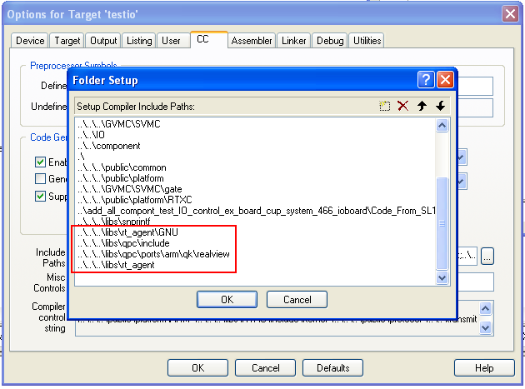
- The last step is including the librtqs.a library which shows in the following picture.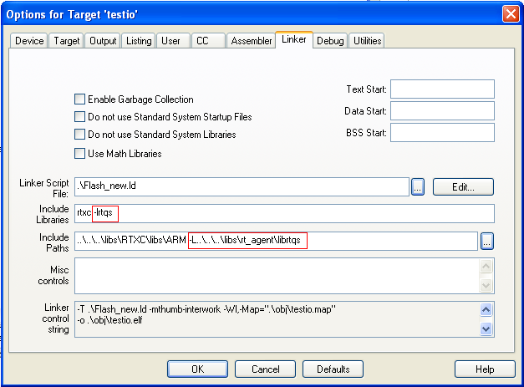
librtqs.a location: http://10.10.0.45/source/trunk/libs/rt_agent/librtqs

After starting the debug session, and open the real-time agent terminal windows, the debug information can be printed out.

Step2→Modify main.c

Include the following file
- component_dbg.h
- qs_rt_agent.h

Add the following line after interrupts_enable(TRUE);
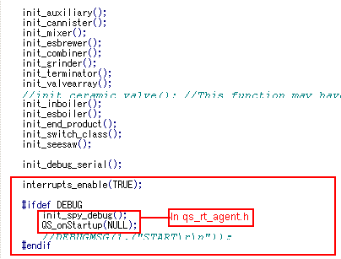

API

void RTDBGPrintf(const char* str,...);

#define DEBUGMSG(cond,printf_exp) ((void)((cond)?(RTDBGPrintf printf_exp),1:0))

